

Bending Moment in a Beam

MECH43023 (Engineering Mechanics)
Student Name: Arpan K Roy
Contents
Introduction 3
Methodology 4
Results 6
Experiment 1 – Bending Moment at the Point of Loading 6
Calculations: 7
Table 1. Results from Experiment 1 8
Experiment 2.1 - Bending Moment Under Single Load at one position. 9
Calculations: 10
Table 2. Results of Experiment 2.1 11
Experiment 2.2 - Bending Moment with Two Loads at Different Positions. 12
Calculations: 13
Table 3. Results of Experiment 2.2 14
Discussion 15
Experiment 1 15
Experiment 2.1 16
Experiment 2.2 17
Conclusion 19
Experiment 1 19
Experiment 2.1 19
Experiment 2.2 19
References 20

Introduction
In structural mechanics, a beam internally resists external forces, making it an important element in engineering design. When an external load is applied, the beam develops an internal stress distribution that transforms the applied force into internal reactions. The resulting bending moment represents the beam's rotational resistance to deformation and determines its capacity to maintain equilibrium under load. By analysing the relation between applied loads, shear forces, and bending moments, engineers predict and optimise the performance of structural components before using them in practical designs. (Chapter 4, ScienceDirect, 2008) The shear force change also affects how the bending moment spreads out, fundamental to analysing internal forces.
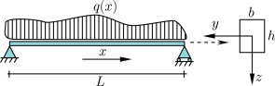
Figure 1. Simple supported beam

According to beam theory, the magnitude of a bending moment at a particular section is obtained by taking the algebraic sum of moments from all the external forces acting on one side of that section. In a simple beam, the moment varies along its length, which produces a bending moment that peaks where the internal stresses are greatest. Moment, M = F x d, provides a direct relation between load intensity and moment’s magnitude, while testing in real-life validates how accurately the theoretical models represent the physical systems. This assignment seeks to connect theory with laboratory experiment by finding the bending moment produced in a simply supported beam enduring load.
The objectives of this research are:
- To determine the variation of the bending moment at the point of loading.
- To evaluate how the bending moment differs along the beam when loads are away from the central cut.
- To compare experimental measurements against theoretical predictions and assess the validity of beam-theory assumptions.
This research interprets bending of the beam as a dynamic interaction of geometry, material stiffness, and equilibrium, which are the foundation upon which all structural and mechanical analysis is structured.

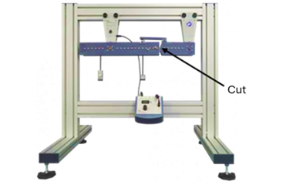
Methodology
The experiment was conducted using a simply supported beam apparatus (Figure 2). The beam includes a cut, a moment arm positioned over the cut so that it transfers the applied force. This setup prevents the beam from failing at the cut while enabling the load cell to record the resulting bending moment. The apparatus also includes a digital force display and a set of weights and hangars for positioning the loads along the beam range.
Figure 2. Structural frame with a simply supported beam apparatus

Before testing, the equipment is set to zero newtons to eliminate any residual readings on the digital force display. The span length L and the moment-arm distance (0.125m) were recorded for further calculations.
Experiment 1 investigated the bending moment at the point of loading. Masses from 0.1 kg to 0.5 kg were positioned at the cut, and the corresponding force readings in the digital force display were recorded.
Experiment 2.1 examined the variation of bending moment for an overhanging load, while Experiment 2.2 examined two-point loads positioned symmetrically. For each configuration, the hooked positions and applied loads were varied systematically, and digital readings were recorded from the digital force displayer. Reaction forces at the supports were calculated using equilibrium equations (∑F=0, ∑M=0), followed by theoretical bending moment evaluation at the cut.
For each experimental configuration (Experiments 1, 2.1, and 2.2), the following procedure was applied:
- Load Application:
The required mass was placed on the weight hanger at the determined location along the beam.
- Force Measurement:
The force transmitted through the moment arm was recorded from the digital force display once equilibrium was reached.
- EBM Calculation:
The experimental bending moment was determined by the following expression,
$$M_{exp}=F_{display}×0.125$$
And compared with the theoretical moment obtained from beam equilibrium.
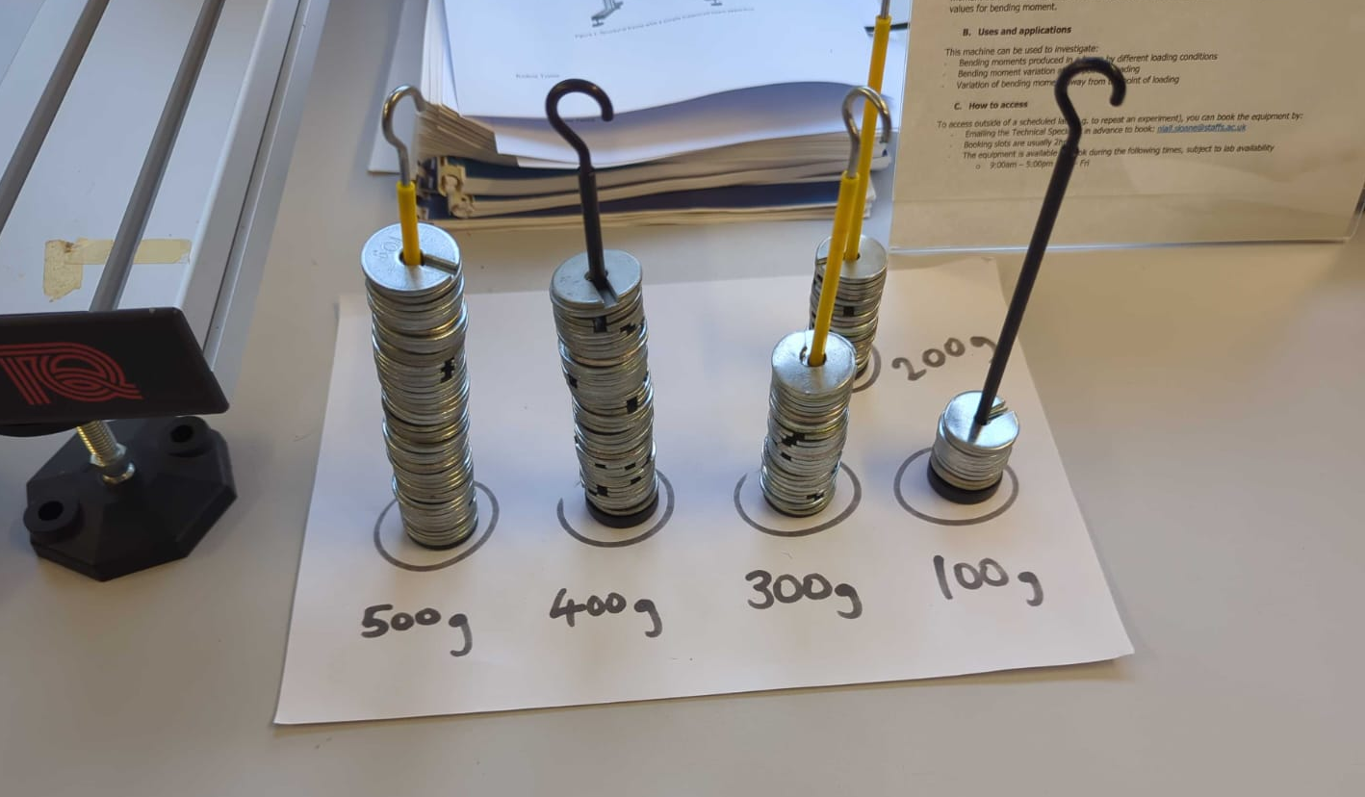
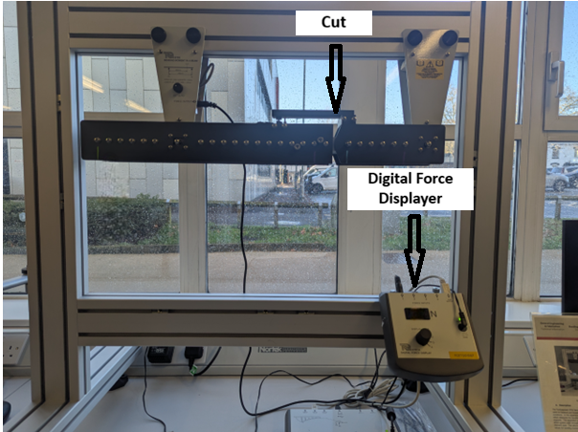
Figure 3. Photograph of Experimental Apparatus and Weight Hangars

Results

Experiment 1 – Bending Moment at the Point of Loading
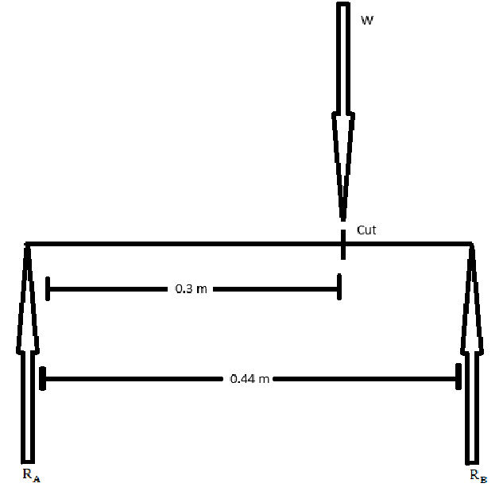
This experiment aimed to verify the relationship between the applied load and the bending moment at the cut section of a simply supported beam. The beam apparatus was levelled, and a hangar was placed at the cut. The masses were increased from 0.1 kg to 0.5 kg and were placed respectively. Figure 4 shows the FBD of the beam.

Figure 4. Free body diagram of the beam

For each applied mass, the load was calculated by
W = mass x gravity
where g = 9.81 $m∕s^{2}$
The theoretical bending moment was then obtained by
Bending moment (at cut) =$W×a×\frac{L-a}{L}$
(Equation 1)
The experimental bending moment was then obtained by
$M_{exp}=F_{display}$×0.125
(Equation 2)


Figure 5 & 6. Photographs of Recorded Experimental Readings

Calculations:
Displayed Force (N) is the reading found from the experiment.
Experimental bending moment (Nm)(using Eq2),
$$0.8×0.125=0.1 Nm$$
$$1.4×0.125=0.175 Nm$$
$$2.1×0.125=0.2625 Nm$$
$$2.8×0.125=0.35 Nm$$
$$3.5×0.125=0.4375 Nm$$
Load (W) (N) = mg,
$$0.1×9.81=0.981 N$$
$$0.2×9.81=1.962 N$$
$$0.3×9.81=2.943 N$$
$$0.4×9.81=3.924 N$$
$$0.5×9.81=4.905 N$$
In the experiment, L and a have constant value,
a = 0.3 m
L = 0.44 m
Theoretical bending moment (Nm)(using Eq1),
$$0.981×0.3×\frac{0.44-0.3}{0.44}=0.0954×0.981=0.0936 Nm$$
$$1.962×0.3×\frac{0.44-0.3}{0.44}=0.0954×1.962=0.1873 Nm$$
$$2.943×0.3×\frac{0.44-0.3}{0.44}=0.0954×2.943=0.281 Nm$$
$$3.924×0.3×\frac{0.44-0.3}{0.44}=0.0954×3.924=0.3745 Nm$$
$$4.905×0.3×\frac{0.44-0.3}{0.44}=0.0954×4.905=0.4682 Nm$$

Table 1. Results from Experiment 1
Figure 7. Theoretical bending moment and Experimental bending moment for Experiment 1

Mass (m)  (kg) | Load (W)  (N) =mg | Displayed  Force (N) | Experimental bending moment (Nm)(using Eq. 2) | a (m) | L  (m) | Theoretical bending moment (Nm)(using Eq. 1) | Percentage error
0.1 | 0.981 | 0.8 | 0.1 | 0.3 | 0.44 | 0.0936 | 6.84%
0.2 | 1.962 | 1.4 | 0.175 | 0.3 | 0.44 | 0.1873 | 6.57%
0.3 | 2.943 | 2.1 | 0.2625 | 0.3 | 0.44 | 0.281 | 6.58%
0.4 | 3.924 | 2.8 | 0.35 | 0.3 | 0.44 | 0.3745 | 6.54%
0.5 | 4.905 | 3.5 | 0.4375 | 0.3 | 0.44 | 0.4682 | 6.56%

Experiment 2.1 - Bending Moment Under Single Load at one position.
A load hanger was placed at the far-left position, as shown in Figures 8 & 9. The force applied by a hanger was measured using a Digital Force Display. The measured force was then converted into a bending moment. Reactions at supports A and B were calculated using the equilibrium equations, $∑F_{y}=0$and $∑M=0$. At last, the experimental bending moment was predicted by beam theory. This setup shows how a single load influences bending moments along the beam.

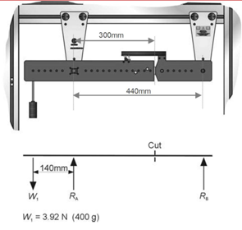
Figure 8. Force Diagram (Overhanging Load)

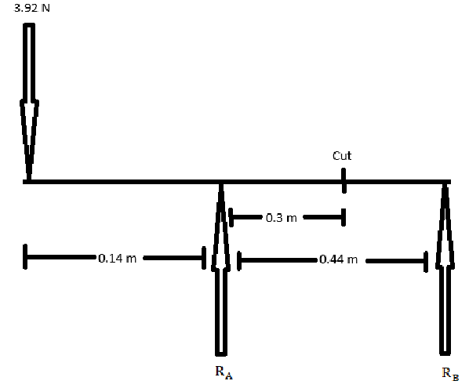

Figure 9. Free Body Diagram (Overhanging Load)

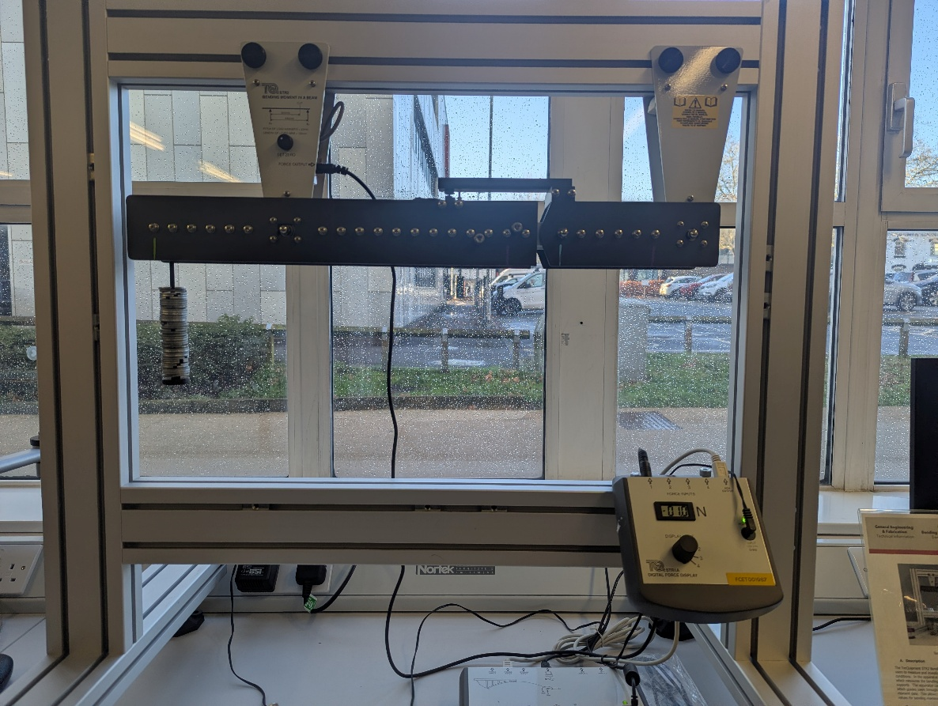

Figure 10. Photograph of Recorded Experimental Reading

Calculations:
Displayed Force (N) is the reading found from the experiment.
Experimental bending moment (Nm)(using Eq2),
$$-1.3×0.125=-0.16 Nm$$
Load (W) (N) = mg,
$$0.4×9.81=3.92 N-(given)$$
At equilibrium,
Taking force in the y-axis, $∑F_{y}=0,$
$$R_{A}+R_{B}=3.92 N-eq.1$$
RA (N),
Taking moments at B, $∑M_{B}=0,$
$$R_{A} x 0.44=3.92 x 0.58$$
$$0.44{ R}_{A}=2.2736$$
$$R_{A}=\frac{2.2736}{0.44}$$
$$R_{A}=5.1672 N-(i)$$
RB (N),
Inserting the value of (i) in Eq. 1
$$R_{B}=3.92-5.2672$$
$$R_{B}=-1.2472 N$$
Theoretical bending moment (Nm),
Taking moments at the cut, $∑M=0$
$$M=5.1672 x 0.3-3.92 x 0.44$$
$$M=1.55016-1.7248$$
$M=-0.17464 N$m

Table 2. Results of Experiment 2.1
Exp. | m1 (kg) | m2 (kg) | Displayed Force (N) | Experimental  bending moment (Nm)(using Eq2) | RA (N) | RB (N) | Theoretical  bending moment (Nm) | Percentage  error
2.1 | 0.4 | 0 | -1.3 | -0.16 | 5.1672 | -1.2472 | -0.17464 | 8.38%

Experiment 2.2 - Bending Moment with Two Loads at Different Positions.
Two different weights were placed at separate positions, as shown in Figures 11 & 12. The forces applied by both hangers were noted using the Digital Force Display and converted into bending moments. Support reactions at A and B were calculated, and the resulting experimental bending moments were compared with theoretical predictions. This experiment demonstrated how bending moments differ with multiple loads at different positions.
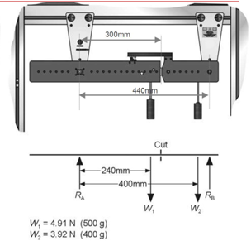
Figure 11. Force Diagram (Two Point Loads)

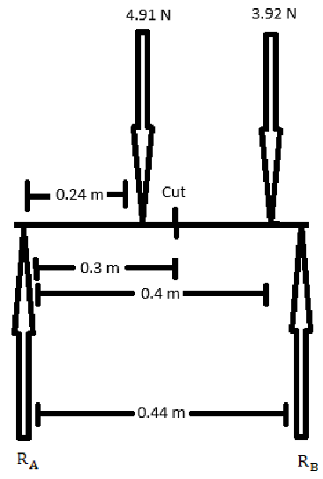

Figure 12. Free Body Diagram (Two Point Loads)

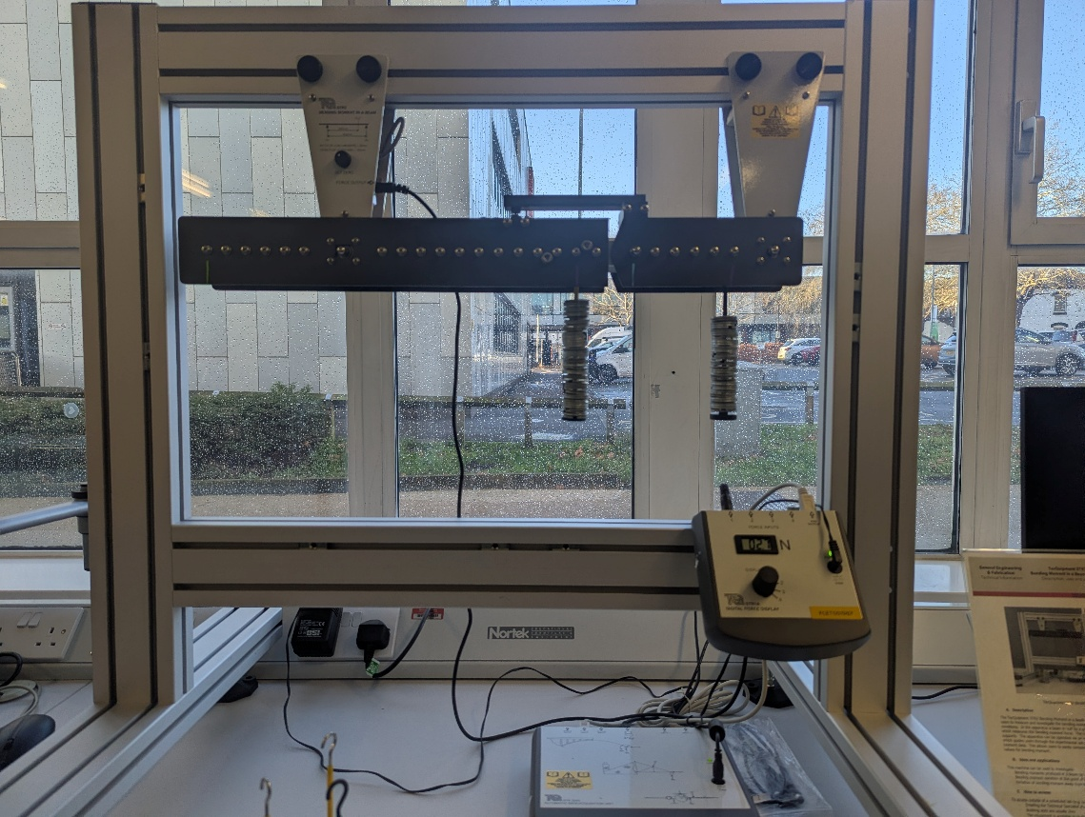

Figure 13. Photograph of Recorded Experimental Reading

Calculations:
Displayed Force (N) is the reading found from the experiment.
Experimental bending moment (Nm)(using Eq2),s
$$3.5×0.125=0.44 Nm$$
Load (W) (N) = mg,
$$0.5×9.81=4.91 N-(given)$$
$$0.4×9.81=3.92 N-(given)$$
At equilibrium,
Taking force in the y-axis, $∑F_{y}=0,$
$$R_{A}+R_{B}=4.91+3.92$$
$$R_{A}+R_{B}=8.83 N-eq.1$$
RB (N),
Taking moments at A, $∑M_{A}=0,$
$$R_{B} x 0.44=3.92 x 0.4+4.91x0.24$$
$$0.44{ R}_{B}=1.568+1.1784$$
$$R_{B}=\frac{2.7464}{0.44}$$
$$R_{B}=6.2418 N-(i)$$
RA (N),
Inserting the value of (i) in Eq. 1
$$R_{A}=8.83-6.2418$$
$$R_{A}=2.5882 N$$
Theoretical bending moment (Nm),
Taking moments at the cut, $∑M=0$
$$M=2.5882 x 0.3-4.91 x 0.06$$
$$M=0.77646-0.2946$$
$M=0.48186 N$m

Table 3. Results of Experiment 2.2
Exp. | m1 (kg) | m2 (kg) | Displayed Force (N) | Experimental  bending moment (Nm)(using Eq2) | RA (N) | RB (N) | Theoretical  bending moment (Nm) | Percentage  Error
2.2 | 0.5 | 0.4 | 3.5 | 0.44 | 2.5882 | 6.2418 | 0.48186 | 8.69%

Discussion

Experiment 1
Under Trends, Patterns, and Comparison of Results, the results show a linear increase in bending moment as the load increases, following beam theory. Theoretical values were slightly higher than experimental values, but both follow the same trend. The percentage error remained constant at 6-7%, showing predictable behaviour across all loads. Most probable discrepancy being, Inaccurate weight hangars, the actual mass may differ slightly from the labelled value.
Predicted or Anomalous?
- The linear increase of bending moment with increasing load was predicted following the beam theory.
- A constant error of 6%+ was predicted.
In a report on beam deflection by Sheffield Hallam University, it quoted that “There still would have been an uncertainty with the measurement of + 0.005mm between experimental and theoretical values”. They reasoned that inaccurately measured support positions and imperfect beam alignment could have resulted in an error. (Pages 28 & 29, Sheffield Hallam University, Jonathan Robinson)

Experiment 2.1
Under Trends, Patterns, and Comparison of Results, the magnitude of the experimental value is slightly lower than theory, giving a percentage error of 8.38%. Since only a single load is applied at the far-left end, the bending moment increases steadily along the beam. Most probable discrepancy being, Apparatus limitations, Mechanical limits can themselves reduce the measured moment; even if the load was positioned exactly as instructed, the experimental setup may not be capable of handling loads at positions far away from supports.
Predicted or Anomalous?
- Negative bending at the cut section for a far left-end load matches the beam theory expectations.
- The percentage of error was predicted and lies within a reasonable range.
Theoretical bending moment (Nm)
Figure 14. Theoretical bending moment and Experimental bending moment for Experiment 2.2

Experimental bending moment (Nm) (using Eq2)

Experiment 2.2
Under Trends, Patterns, and Comparison of Results, the beam was loaded with two weights, and hence the bending moment at the cut is influenced by both loads. The experimental bending moment is higher than the theoretical. Most probable discrepancy being Sensor Output Deviations at Higher Loads, the sensor may act differently when two loads act simultaneously at different positions, hence leading to a different reading than predicted by theory.
Predicted or Anomalous?
- High Bending moment with multiple loads is predicted.
- Percentage error is anomalous and is consistent with reports of calibration offsets and load misplacements.
The University of Warwick thesis provides direct experimental evidence that the experimental bending moment may result from sensor deviations and support friction. Chen notes that “knife-edge fixtures ... exert a constraint”, creating a frictional moment that systematically shifts measurements. (p. 87, University of Warwick, Chen, March 2000)
Figure 15. Theoretical bending moment and Experimental bending moment for Experiment 2.2

Common discrepancies for all experiments:
- Placement Errors,
Small inaccuracies in the position of either load lead to different values that affect the overall bending moment.
- Environmental factors (possible reason),
Slight vibration or oscillation can temporarily increase readings
- Weight Variations (possible reason)
The weights may not be perfectly accurate, causing slight variations in the actual load.

Conclusion
The key findings from the experiments were,

Experiment 1
- Both experimental and theoretical bending moments were calculated after applying multiple loads from 0.1-0.5 kg at the cut.
- The smallest load showed a higher percentage error, however at higher loads the percentage error remained lower.
- The cause could be non-linearity of the measuring device at higher loads and slight misalignment of supports.

Experiment 2.1
- A load of 0.4 kg was placed at one end, and the bending moments at the cut were measured for comparison.
- Experimental bending moment was slightly lower than theoretical, due to apparatus limitations with distant loads.

Experiment 2.2
- Two loads, 0.5 kg and 0.4 kg, were applied at different positions, and the bending moments were calculated.
- Experimental bending moment was higher than the theoretical, and the discrepancy likely came from sensor variations under multiple loads.
Common real-life example,
- A shelf with a single object placed near the centre behaves like a supported beam with one applied load.
- When an object is placed at the edge of the shelf, it mimics an overhanging load condition.
- Placing two objects at different points on the shelf replicates the effect of two separate point loads, just like two loads applied at different positions.

References
- Beam Bending – ScienceDirect, Chapter 4 - Voigt and Reuss bounds
Available at:
https://www.sciencedirect.com/topics/engineering/beam-bending
[Accessed on 14 November 2025]
- Jonathan Robinson, Bending Beams Laboratory Report Aerospace Engineering Principles – Sheffield Hallam University
Available at:
https://www.studocu.com/en-gb/document/sheffield-hallam-university/aerodynamic-principles/bending-beams-report-grade-1st/1461514
[Accessed on 21 November 2025]
- Chen, X., Experimental study of beam behaviour and support friction effects, University of Warwick.
Available at:
https://wrap.warwick.ac.uk/id/eprint/67042/
[Accessed on 21 November 2025]

